Assignment No.: 10
Problem Statement: Deploy a project from to GitHub to EC2 by creating a new security group and user data.
Solution: 1.At first login to your AWS account and then go to EC2.
- Create security group.
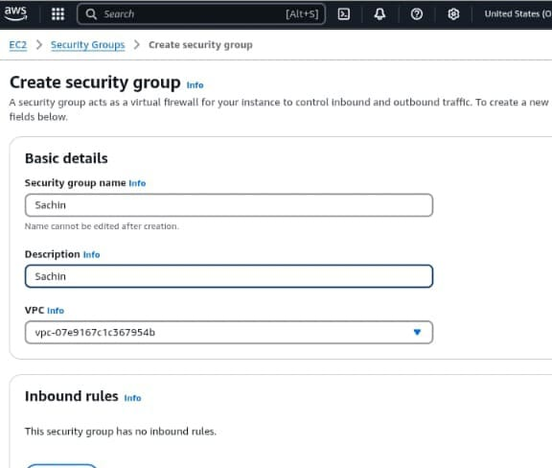
- Set inbound rules.
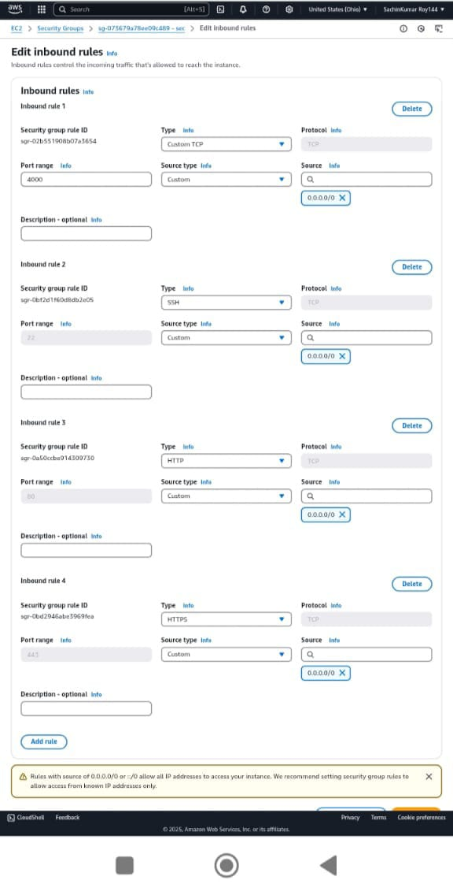
- Then create a Key pair for your instance by giving the name, type and private key file format.
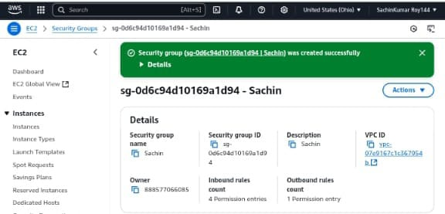

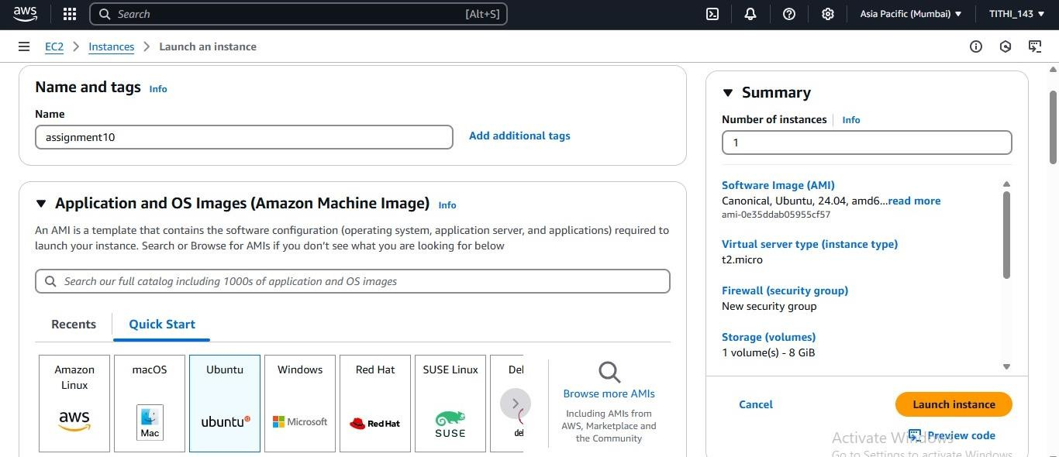
- Then give the instance name and select the platform. (Here we are using Ubuntu).
- Click (Select existing security group) and select security group.
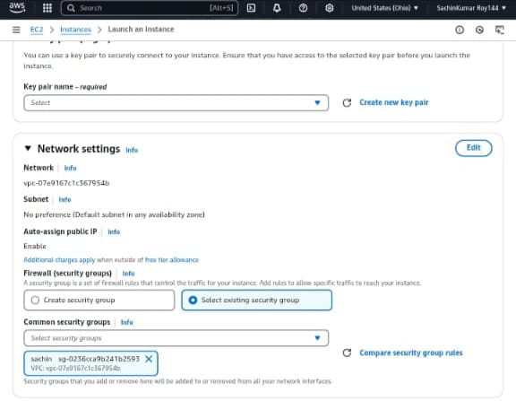

- Write code in the box, and click on Launch instance.
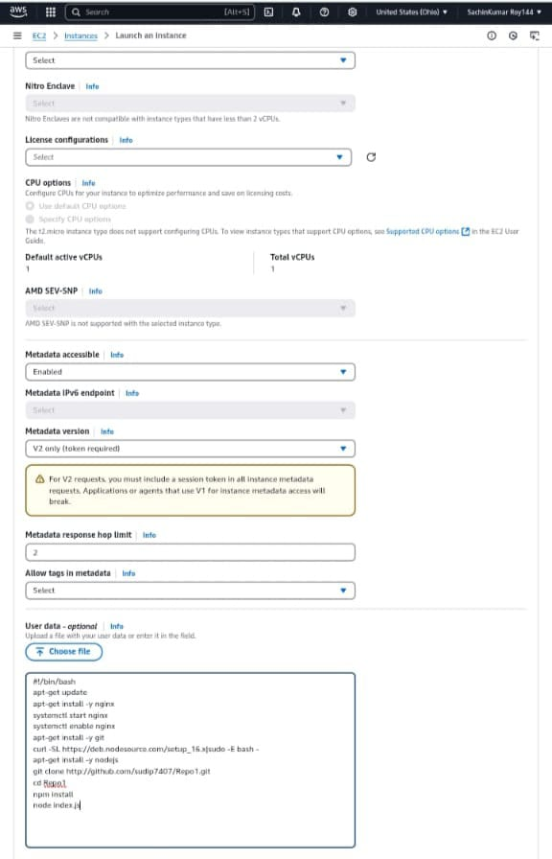

- After successfully launch instance ,copy the public IPV4 address and paste in the address bar.
